St. Joseph Cupertino Fraternity
Enkindle the Fire of Mercy in our Hearts
Gathering – May 15, 2016 – 1 PM to 4 PM

Laudato Si (Praise be to you – On Care For Our Common Home), Paragraph 12

“The urgent challenge to protect our common home includes a concern to bring the whole human family together to seek a sustainable and integral development, for we know that things can change. The Creator does not abandon us; he never forsakes his loving plan or repents of having created us. Humanity still has the ability to work together in building our common home. Here I want to recognize, encourage and thank all those striving in countless ways to guarantee the protection of the home which we share. Particular appreciation is owed to those who tirelessly seek to resolve the tragic effects of environmental degradation on the lives of the world’s poorest. Young people demand change. They wonder how anyone can claim to be building a better future without thinking of the environmental crisis and the sufferings of the excluded.” ~ Pope Francis

Dear Sisters and Brothers in Francis and Clare,

Our next Gathering will be Sunday, May 15, 2016, Mass will begin at 12:00 pm and our social time will start at 1 pm in the refectory, please bring a lunch and drink. Our fraternity elections will start promptly at
2 pm. Below is the slate of nominees so far:

Minister – Bob Longo, OFS
Vice-Minister –Ed Burgee, OFS
Secretary – France Staudenmann, OFS
Treasurer – Michael Radcliffe, OFS
Formation – Geri Flynn, OFS
Councilor – Lita Maisel, OFS

Nominations will be accepted from the floor

The current council of St. Joseph Cupertino Fraternity would like to “THANK YOU” for your willingness to be servant leaders for the next three years.

All professed are requested to attend. A quorum of active professed members is needed to conduct an election (one half plus 1). Without a quorum, the elections will need to be postponed to a subsequent meeting. Please bring your Ritual Book

Visitors, Aspirants, inquirers and candidates are encouraged to attend; this is a wonderful experience to see the inner workings of the structure of the fraternity. Several of our candidates have volunteered to help with our upcoming elections. ~ Your Fraternity Council

+

Our Fraternity Council

Minister: Bob Longo, OFS
410-921-0040
V. Minister: Sherry Lewis, OFS
410-788-5395
Formation: Geri Flynn, OFS
410 730-4395
Secretary: France
Staudenmann OFS
301-294-3085
Acting
Treasurer: Jerry Yu, OFS
410 988-5753
Councilors: Lita Maisel OFS
410 747-2374
Cindy Mohler, OFS
410 747-4589 Spiritual Assistant:
Br. Lawrence LaFlame, OFM. Conv
410 531-2800

Page 1

We will close our Elections with Evening Prayer


Evening Prayer II for Pentecost Sunday

Marian devotion of St. Francis
No Saint was the image of Christ as St. Francis of Assisi. Now, between Jesus and Mary there is the greater unity imaginable. So, between St. Francis and Our Lady there was the closest possible union between holy souls. Herald of the great King, singer of the most exquisite poetry that the soul knows, Francis was also the most tender son of Mary.
All actions of Francis headed in the light of Christ and his Blessed Mother. St. Bonaventure, in his "Legend Maggiore" writes:
"Sheltered also this church, a place called Portiuncula, in which it was originally dedicated to the Blessed Virgin was then, however, abandoned and not taken care of by anyone. When the man of God saw her so abandoned, driven by his fervent devotion to the Queen of the world, he began to dwell assiduously in that place, with the intent to repair it.
This holy place he loved more than all the other places in the world. Here, in fact, humbly began, progressed virtuously here; here happily came to fruition. This place, at the time of death, he recommended to the brothers as the most dear to the Virgin. "(LegM, n. 1048) San Francesco wanted to better contemplate the mystery of Jesus: he wanted to reflect in her soul and her children the beauty of Mary, to ignite in them the love of God. Even St. Bonaventure says: "surrounded with indescribable love the Mother of the Lord Jesus, to the fact that has made ​​our brother the Lord of Majesty, and we got the mercy. In her mainly, after that in Christ, he placed his trust, and therefore constituted his lawyer and his people. In his honor was fasting with great devotion the feast of the Apostles Peter and Paul until the feast of the Assumption "(LegM, n. 1165).
Marian devotion of St. Francis developed with the apostolic activity of his life and is manifested in all its private and public acts. Francis left few writings related to Mary, but they are enough to make us understand the ardent love he had to her; in the "Salutation of the Blessed Virgin Mary", he sums up his entire devotion to her: "Hail Lady, Holy Queen, Holy Mother of God, Mary, Who are the Virgin made ​​Church, in whom there was and is all fullness of grace and every good. His palace Ave, His tabernacle, Hail His house, Ave, his garment Hail His Servant! Hail His Mother. (...) "; in his "Office of the Passion" he says: "Holy Virgin Mary, in the world among women not born no one like you, daughter and handmaid of the Most High King, the heavenly Father, Mother of our most Holy Lord Jesus Christ, spouse Holy Spirit. " And yet, Thomas of Celano writes: "The heart of Francis burned with fervent devotion and singular love for the heavenly Mother. In her, after Jesus, was all his trust. "

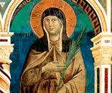

Please Pray For …

Connie Baker, OFS
Donna Duncan, OFS
Marlene Feaga, OFS
Mary Ferrara, OFS
Marie Lindung, OFS
Jim Manning, OFS
Georgianna Papazian, OFS
Nancy Seaton, OFS
Jim Tebo, OFS

Page 2

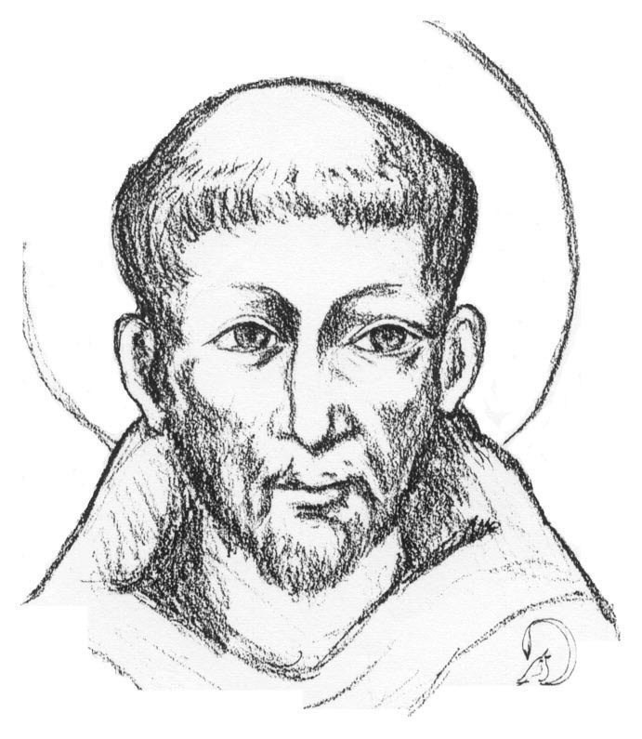
OUR DECEASED BROTHERS AND SISTERS

Deacon Tom Bello, OFS
Frances Bastress, SFO
Joe Bezila, SFO
Jerry Cichowicz, SFO
Shirley Costello, OFS
Joe Cykoski, SFO
Stella Cykoski, SFO
Claire Lee Davison, SFO
Adela Duff, SFO
Charles Ferrara, SFO
Dolores Fritz, OFS
Marilyn Gilson, SFO
Richard Hall, SFO
Joy Kubricky, OFS Frances Langbehn, SFO
Bob Lewis, SFO
Jean Manning, OFS
Yvonne Proch, SFO
Betty Taylor, SFO
Bud Tenley, SFO
Regina Yeager, SFO
Dorothy Zalewski, SFO
Why I Took the Name Francis

There are various reasons why I chose the name of Francis of Assisi, a familiar figure far beyond the borders of Italy and Europe, even among those who do not profess the Catholic faith. One of the first reasons was Francis’ love for the poor. How many poor people there still are in the world! And how great the suffering they must endure! After the example of Francis of Assisi, the Church in every corner of the globe has always tried to care for and look after those who suffer from want, and I think that in many countries we can attest to the generous activity of Christians who dedicate themselves to helping the sick, orphans, the homeless and the marginalized, thus striving to make society more humane and more just.

But there is also another form of poverty. It is the spiritual poverty of our time, which afflicts the so-called richer countries particularly seriously. It is what my much-loved predecessor, Benedict XVI, called the 'tyranny of relativism', which makes everyone his own criterion and endangers the coexistence of peoples. And that brings me to the second reason for which I chose my name. Francis of Assisi tells us we should work to build peace. But there is no true peace without truth! There cannot be true peace if everyone is his own criterion, if everyone can always claim exclusively his own rights, without at the same time caring for the good of others, of everyone, on the basis of the nature that unites every human being on this earth. One of the titles of the Bishop of Rome is Pontiff, that is, a builder of bridges with God and between people."

Dialogue between us should help to build bridges connecting all people, in such a way that everyone can see in the other not an enemy, not a rival, but a brother or sister to be welcomed and embraced! Moreover, his own origins impel me to work for the building of bridges. In fact, my family is of Italian origin; and so this dialogue between places and cultures a great distance apart matters greatly to me, this dialogue between one end of the world and the other, which today are growing ever closer, more interdependent, more in need of opportunities to meet and to create real spaces of authentic fraternity. The role of religion is fundamental in this work: It is not possible to establish true links with God, while ignoring other people.

And it is also important to intensify outreach to non-believers, so that the differences which divide and hurt us may never prevail, but rather the desire to build true links of friendship between all peoples, despite their diversity. Therefore fighting poverty, both material and spiritual, building peace and constructing bridges are the focal points of a journey that I want to invite all to take up. A difficult journey if we do not learn to grow in love for this world of ours. Here too, it helps me to think of the name of Francis, who teaches us profound respect for the whole of creation and the protection of our environment, which all too often, instead of using for the good, we exploit greedily.

~ Pope Francis



May - 2016

Beginning Balance: $ 858.71
Income 617.00
Total $2,253.71
Expenses:

Franciscan Friars 100.00
Brother Lawrence 50.00
Website Fee 15.00
To Fr. Bayne 100.00
To the Shrine 20.00
Total Expenses: $ 285.00

Ending Balance: $1,190.71

Thank You for your monthly contributions

Contribution is Tax Deductible

May Birthdays


Jim O’Brien, OFS 05/14
Lynne Float, OFS 05/17
Patrick Caughy, OFS 05/18
Carl Fischer. OFS 05/26
Ray Heverling, OFS 05/31
__________________________

Food for Thought
The corporal and spiritual works of mercy remind us that our faith translate into concrete and everyday gestures, intended to help our neighbor in body and in spirit and on which we shall be judged: To nurture, To visit, Comfort him and educate him. – Pope Francis

Page 3
+-659
Ten Simple Rules for Daily Living
The Daily Decalogue of Pope St. John XXIII SFO

1) Only for today, I will seek to live the livelong day positively without wishing to solve the problems of my life all at once.
2) Only for today, I will take the greatest care of my appearance: I will dress modestly; I will not raise my voice; I will be courteous in my behavior; I will not criticize anyone; I will not claim to improve or to discipline anyone except myself.
3) Only for today, I will be happy in the certainty that I was created to be happy, not only in the other world but also in this one.
4) Only for today, I will adapt to circumstances, without requiring all circumstances to be adapted to my own wishes.
5) Only for today, I will devote 10 minutes of my time to some good reading, remembering that just as food is necessary to the life of the body, so good reading is necessary to the life of the soul.
6) Only for today, I will do one good deed and not tell anyone about it.
7) Only for today, I will do at least one thing I do not like doing; and if my feelings are hurt, I will make sure that no one notices.
8) Only for today, I will make a plan for myself: I may not follow it to the letter, but I will make it. And I will be on guard against two evils: hastiness and indecision.
9) Only for today, I will firmly believe, despite appearances, that the good providence of God cares for me as no one else who exists in this world.
10) Only for today, I will have no fears. In particular, I will not be afraid to enjoy what is beautiful and to believe in goodness. Indeed, for 12 hours I can certainly do what might cause me consternation were I to believe I had to do it all my life.
To conclude: here is an all-embracing resolution: "I want to be kind, today and always, to everyone."
In this way, we can put Pope John's hope for every Christian into practice: "Every believer in this world must be a spark of light, a core of love, life-giving leaven in the mass: and the more he is so, the more he will live, in his innermost depths, in communion with God."

At the Friary

Chapel Open Daily
From 9 AM – 5 PM

Noon Mass everyday

All are Welcome
____________________________________
Reconciliation

Wednesdays from 4 - 5pm., and Monday through Saturday at 11:30am.

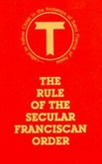

Rule 22 of the
Secular Franciscan Order

The local fraternity is to be established canonically. It becomes the basic unit of the whole Order and a visible sign of the Church, the community of love. This should be the privileged place for developing a sense of Church and the Franciscan vocation and for enlivening the apostolic life of its members.

OUR GATHERINGS –Members should make every effort to attend our gathering every month. If you are unable to attend due to illness, work or family obligations, contact a council member (see page 1 for telephone numbers). If you are a candidate or are professed and miss a gathering, please send your check for the Common Fund to:

Jerry Yu, OFS
2812 Green Shade, Ct.
Ellicott City, MD 21042

Editor: Bob Longo, OFS blongosfo@gmail.com Fraternity Website: http://stjosephcupertino.sfousa.org/
Page 4

